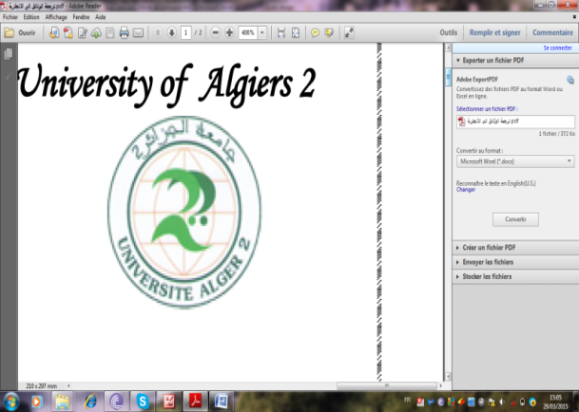
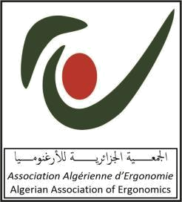
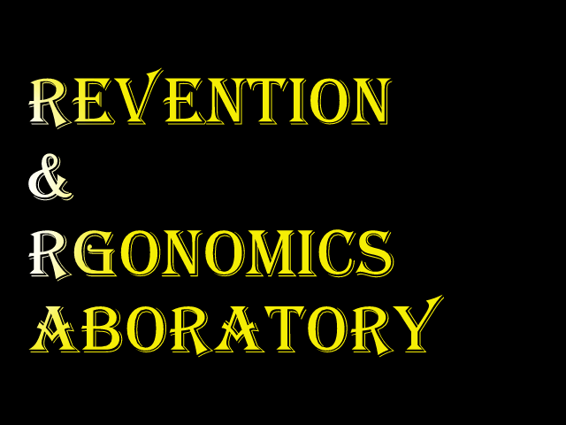


Algerian Association of Ergonomics | University d'Algérie 2 | Laboratory of Prevention and Ergonomics

 Fourth International Conference on Ergonomics

 Applications of Ergonomics in Developing Countries:
Under the slogan: " Culture and Development "
[April 28-29, 2024, Conference Auditorium, University of Algiers 2]
CALL FOR PARTICIPATION
- Introduction:
The Laboratory of Prevention and Ergonomics of the University of Algiers2, in cooperation with the Algerian Association of Ergonomics, organizes the Fourth International Conference on: Applications of ergonomics in developing countries: " Culture and Development ", on the occasion of the International Day of Safety and Health at Work, April 28-29, 2024, Conference Auditorium, University of Algiers 2, Algeria. The conference will be open to all researchers and specialists in various fields to share their research and experiences in the field, as well as to other interested persons in the various disciplines and to all sectors concerned.
- Problematic of the conference:
Ergonomics is a modern applied science that aims to make the requirements of products, professions, workplaces, tools, equipment and various facilities suitable for the individuals who will use them in order to raise the level of the man-machine system by adapting working conditions to the nature of human physiological and psychological capabilities and structure. It is concerned with designing and arranging things used by workers or general public so that people and things interact with the greatest efficiency and safety. In doing so, it seeks to design equipment and work tasks to match the ability of the worker, as it seeks to modify the work environment and work practices to prevent injuries before they occur. By systematically reducing risk factors, ergonomics aims to prevent high costs of musculoskeletal disorders, increase work efficiency and productivity, enhance safety and satisfaction in the workplace, reduce physical and mental workloads, improve quality, employee engagement and create a better safety culture by making it as a top priority that needs the contribution and cooperation of everyone.
Perhaps the developing countries are in need to work on benefiting from the principles of ergonomics and the consolidation of a culture of safety more than the developed countries in the light of the rapid developments and changes they are going through at the economic and technological level. This is especially in facing their cultures, traditions and social behaviours that may not keep pace with the requirements of development that it seeks to be achieved. Many studies on worker productivity and occupational safety and health issues in developing countries have confirmed that ergonomics has little or no application. In addition, the workers did not receive any training in ergonomics, and that the occupational hazards and health problems of the workers indicate a deficiency in the application of ergonomics. So, working conditions in developing countries are in urgent need of the application of ergonomics. That is why this conference came to contribute to raising awareness of ergonomics, and encourage its application in developing countries to seek the benefit from the principles and applications of ergonomics in order to achieve a culture of prevention and development to ensure a better future.
- Objectives of the Conference:
The Fourth International conference seeks to achieve the following objectives:
- Application of ergonomics in the field of work tools, instruments and its traditional methods.
- Activation of the application of ergonomics in the field of technology transfer to developing countries.
- Application of ergonomics in the field of industrial security and in facing various accidents.
- Diffusion of ergonomic knowledge through universities, conferences, books and scientific journals in developing countries.
- Diffusing the mechanisms of effective application of ergonomics knowledge in developing countries in various sectors.
- Providing services for people with special needs to adapt to their professional and social surroundings.
- The importance of ergonomics in sensitizing society about how to deal with disasters and pandemics
- Highlighting ways to benefit from the experiences of industrially developed countries in the application of ergonomics in various sectors.
- Topics of the Conference:
- Application of ergonomics in the field of agriculture.
- Application of ergonomics in the field of health sector.
- Application of ergonomics in the field of services.
- The role of ergonomics in improving working conditions.
- Application of ergonomics in the field of developing work tools.
- The application of ergonomics in the field of industrial safety and dealing with various accidents.
- Adapting the principles of ergonomics in the field of technology transfer to be in line with the culture, traditions and custom of developing countries.
- Mechanisms of effective application of ergonomics in developing countries in various sectors.
- Ways to benefit from the experiences of industrially developed countries in the application of ergonomics in various sectors.
- Participants:
- Professors, researchers and university students, research center and specialized institutes.
- Occupational physicians and other health professionals concerned with ergonomics, prevention and security at work.
- Design engineers and industrial safety and security engineers.
- Managers and specialists in the management of human resources.
- Managers and employees of various economic and social institutions.
- Related organizations, businessmen and all those interested in ergonomics.
- Conditions for participation in the conference:
- The participant should submit a research related to one of the axes of the conference and must not be the subject of a previous publication or submission to another scientific act.
- Research must be presented in Arabic, French or English, provided the level of the language and layout is very high.
- The research must be characterized by seriousness and modernity and must rely on scientific methodological rules and recent references.
- Priority is given to practical research work and accepted articles may be published in the Journal de Prevention & Ergonomie or the in the proceedings of the conference.
- The full scientific paper should be sent before January 31, 2024, via the e-mail shown below.
- The paper must not exceed 20 pages according to the model of the seminar (see link below announcement) or to be consulted on: https://www.asjp.cerist.dz/revues/448/uploads/edit
- The registration form must be filled out accurately in case of final acceptance.
- Important dates:
- Scientific papers: January 31, 2024. (It is recommended to send it early to get an early response).
- The deadline for notifying the final accepted submissions is: February 29, 2024.
- Facilities of participation in the conference:
- No participating fees are required.
- Simultaneous translation into the three languages: Arabic, French and English, is provided during interventions.
- Catering and accommodation for speakers and guests during the days of the conference will be at the expense of the conference organizers.
- Speakers and guest will get a free copy of the proceedings of the third International Conference about: “Applications of Ergonomics in developing countries: " Ergonomics Culture and Development ", 2024.
- Airline Tickets are on the Participant’s expense.
- Transportation from the airport to the hotel is provided only for speakers coming from outside Algeria.
- Contact information:
All correspondences go to Chairman of the Scientific Committee:
Professor: Hamou Boudrifa
Head of the Laboratory of Prevention and Ergonomics, University of Algiers2. Algiers.
&
President of the Algerian Association of Ergonomics
E-mail: ergo.assoc.dz@hotmail.com
Tél / Fax : (213) 23 18 01 17 & (213) 23 18 07 83 // (213) 661570761
https//prevention-ergonomics.com/en/seminaire.html
- Scientific committee:
Nom & Prénom | Institution | Country
- Pr. Boudrifa Hamou | University of Algiers 2 | Algeria
- Pr. Mokdad Mohamed | University of Bahrein. | Bahrein.
- Pr. Mebarki Bouhafs | University of Oran 2 | Algeria
- Pr. Bouabdallah Lahcène | University of Sétif2 | Algeria
- Pr. Achoui Mustapha | King Fahd University of Petroleum & Minerals (previously) | Saudi Arabia
- Pr. Bahmed Lylia | University of Batna 1 | Algeria
- Pr. Aissi Mohamed | E.N.S. of Kouba | Algeria
- Pr. Ait Hamouda Karima | University of Algiers 2 | Algeria
- Pr. Meziani Fatiha | University of Algiers 2 | Algeria
- Pr. Namouni Mourad | University of Blida2 | Algeria
- Pr. Meziani Lounes | University of Ourgla | Algeria
- Pr. Hayette Benmessaoud | Head of Occupational Medicine Department, CHE, Bab El Oued | Algeria
- Pr. Abidatte Hani | Yarmouk University / Hashemite Kingdom of Jordan | Jordan
- Pr. Job Remo | University of Trento, Italy | Italy
- Pr. Abeysekera John | Work Science Academy | Sweden
- Pr. Dhurjati Majumdar | Indraprastha Institute of Information Technology Delhi | India
- Pr. Gangopadhyay Somnath | University of Calcutta, | India
- Pr. Bendak Salaheddine | Haliç University | Turky
- Pr. Denis A. Coelho | Jönköping University | Sweden
- Pr. Abada Mhmadi | University Tunis El Manar | Tunisia
- Pr. Mahfoudh Aouatef | University Tunis El Manar | Tunisia
- Pr. Irtyah Merchaoui | University of Monastir | Tunisia
- Pr. Fasla Elhadi | University of Oran2 | Algeria
- Pr. Ouaaz Meriem | Hopital of Rouiba, University of Algiers 1 | Algeria
- Pr. Keffan Salim | University of Sétif 2 | Algeria
- Pr. Boutebal Saad Eddine | University of Khemis Miliana | Algeria
- Pr. Sahraoui Wafia | University of Algiers 2 | Algeria
- Pr. Charifi Hana | University of Algiers 2 | Algeria
- Pr. Mihoubi Faouzi | University of Blida 2 | Algeria
- Pr. Argoub Mohamed | University of Oran | Algeria
- Pr. Bouattit Sofiane | University of Skikda | Algeria
- Dr. almomani Ali jehad | Amman Arab University | Jordan
- Dr. Hachelafi Hamid | University of Oran2 | Algeria
- Dr. Ojolo Sunday Joshua | University of Lagos | Nigeria
- Dr. Olugbenga Bejide | Sheencare Medical Services Limited, Abuja | Nigeria
- Dr. Kapila Jayaratne | Sri Lanka Medical Association | Sri Lanka
- Dr. Prasanna Illankoon | University of Moratuwa, Sri Lanka | Sri Lanka
- Muhammad Gabr Al-Said Abdu-Allah Gameel | Al-Madinah International University, Cairo, Egypt | Egypt
- Dr. Mercy Kuma -Kpobee | University of Ghana | Ghana
- Dr. Frihat Imène | University of practical Balquan | Jordan
- Dr. Koussa Falima Zouhra | University of Continuing Education | Algeria
- Dr. Benguesmi Dhaouia | University of Continuing Education | Algeria
- Dr. Guezoui djedjiga | University of Algiers 2 | Algeria
- Dr. Maaref Souad | University of Batna2 | Algeria
- Dr. Saadia Saadi | University of Batna2 | Algeria
- Dr. Chettouh Samia | University of Batna2 | Algeria
- Dr. Mhamed Bengharbi | University of Tlemcen | Algeria
- Dr. Oubrahem Ouiza | University Of Tiaret | Algeria
- Khatib Zoulikha | University of Oran
- Dr. Hamdada Leila | University of Tiaret | Algeria
- Dr Banyahia Sabrina | University of Blida | Algeria
- Committee of Organisation:
N° | Nom & Prénon | Qualité | Grade | Institution
 | Pr. Boudrifa Hamou | Président | Professeur | University d’Alger2
 | Dr. Koussa F. Zouhra | Member | Maitre de conférences A | Univ de la Form Cont
 | Dr. Benkacemi Dhaouia | Member | Maitre de conférences A | Univ de la Form Cont
 | Aissa Bayoub | Member | Doctorant | University d’Alger2
 | Ablache Assia | Member | Doctorant | University d’Alger2
 | Bechim Riadh | Member | Master student | University d’Alger2
 | Bentalha Younes | Member | Master student | University d’Alger2
 | Hadj said Fatiha | Member | Doctorante | University d’Alger2
 | Boukroucha Slimane | Member | Doctorant | University d’Alger2
 | Mecene Amine | Member | Doctorant | University d’Alger2
Participation form*
Applications of ergonomics in developing countries:
Under the slogan: "Culture and Development"
[April 28-29, 2024, Conference Auditorium, University of Algiers 2]
- This form should be sent alone with the full paper
Sex : ( ) Masculin ( ) Féminin |  |  | Name and surname:
Function: | Specialization: |  |  | Grade:
Institution:
Phone number: |  | E-mail :
Axe of intervention :
Title of the intervention:

